Name ________________________
UNIT 1 -NATURE OF SCIENCE 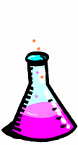

Use your textbook (see the index), scientific dictionaries, class discussion, and the internet to find these answers!

NS.10.B.1 Explain why science is limited to natural explanations of how the world works.

- Scientists use the S______________ M____________ to explain the real world.
- All scientific experimentation starts with O______________ of the natural world.

NS.10.B.2 Compare and contrast hypotheses, theories, and laws.
- What is a hypothesis?
- Define theory.

- Define scientific laws.

- Give an example of a scientific theory.

- Give an example of a scientific law.
NS.10.B.3 Distinguish between a scientific theory and the term “theory” used in general conversation.
- Scientific Theory -

- I have a “Theory” -

NS.10.B.4 Summarize the guidelines of science: (HINT: COMPLETE THE THOUGHTS.)
- Hypotheses must be T_________________ to be accepted.
- D___________ is collected during an experiment and must be organized into T____________ or G_____________.
- A hypothesis may be Ch____________ if it isn’t supported by data.
- Scientific testing must have P__________ review and verification before being accepted and P_____________ in scientific journals.

NS.11.B.1 Explain the controls and variables (dependent and independent) in scientific experimentation.
- Why must you have a control?

- What is meant by the dependent Variable?

- On which axis would you graph the dependent variable?

- What is meant by the independent Variable?
- On which axis would you graph the independent variable?

- If you were measuring the growth rate of plants under full sunlight for 8 hours a day versus plants that only have 4 hours of full sunlight per day, what would be the dependent and what would be the independent variable?

_________________________ Dependent variable

_________________________ Independent variable

NS.14.B.1 Compare and contrast biological concepts in pure science and applied science.
- What is pure Science and include an example.

- What is applied Science and include an example.

NS.14.B.2 Discuss why scientists should work within ethical parameters.
- What does ethical mean?

- Why must scientists be ethical about their work?

UNIT 2 - MOLECULES & CELLS 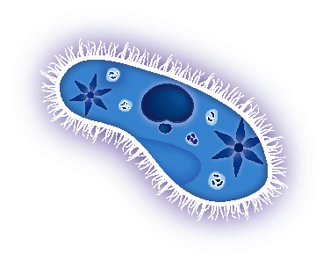 Biochemistry
Most topics covered in Chapter 1 -3 of HRW Modern Biology!

MC.1.B.1 Describe the structure and function of the major organic molecules found in living systems:

- CARBOHYDRATES Elements __________ Ratio ________

  - DEFINITION -

  - EXAMPLES –
Monosaccharide | Disaccharide | Polysaccharide
glucose | Sucrose | Glycogen
fructose | Maltose | Starch
galactose | lactose | Cellulose/chitin
  - MONOMERS –

  - USES –
  - Ending?

- PROTEINS Elements ______________

  - DEFINITION -

  - EXAMPLES –
  - MONOMERS –
  - USES –

- ENZYMES

  - DEFINITION -

  - EXAMPLES –

  - MONOMERS –

  - USES –

- LIPIDS

  - DEFINITION -
  - EXAMPLES –
  - MONOMERS –

  - USES –

- NUCLEIC ACIDS

  - DEFINITION -

  - EXAMPLES –

  - MONOMERS –

  - USES –

MC.1.B.2 Describe the relationship between an ENZYME and its substrate molecule(s
- DEFINE SUBSTRATE.

- AN ENZYME IS WHAT TYPE OF MOLECULE?

- EXPLAIN INDUCED FIT.

- DEFINE DENATURATION.

- NAME 3 THINGS THAT CAN DENATURE ENZYMES. (number these)

- SKETCH AN ENZYME AND SUBSTRATE. LABEL ENZYME, ACTIVE SITE, & SUBSTRATE.

MC.1.B.3 Investigate the properties and importance of WATER and its significance for life:
- WHAT PROPERTY OF WATER CAUSES ITS UNIQUE CHARACTERISTICS?

- DEFINE SURFACE TENSION.

- EXPLAIN HOW SURFACE TENSION HELPS ORGANISMS.

- DEFINE ADHESION.

- DEFINE COHESION.

- EXPLAIN POLARITY.

- IS WATER A POLAR OR NONPOLAR MOLECULE?

- CIRCLE WHICH OF THE FOLLOWING WILL DISSOLVE IN WATER --- wax, salts, alcohol, sugars & starches, oil, polar proteins.

- EXPLAIN THE PH SCALE.

- WHAT pH WOULD PURE WATER BE?
- WHAT IS THE PH OF ACIDS?
- WHAT IS THE PH OF BASES?
- WHAT IS NEUTRALIZATION?

MC.2.B.1 Construct a HIERARCHY of life from cells to the biosphere. (Use the index of your textbook for help as you may need to look at more than one chapter)

CELL _T_________ _O_________ S__________

ORGANISM _P_______________ _C_____________

E_____________ BIOSPHERE

UNIT 3 - MOLECULES & CELLS – Cells & Energetics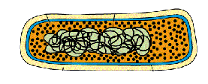
Most topics covered in Chapter 4 -7 of HRW Modern Biology!

MC.2.B.2 Compare and contrast prokaryotes and eukaryotes.
- Define prokaryote and give an example.

- Define eukaryotes and give an example.

MC.2.B.3 Describe the role of sub-cellular structures in the life of a cell:
- Define organelles.

- Give the function and location of ribosomes.

- Tell the function and describe the structure of the cytoskeleton.

MC.2.B.4 Relate the function of the plasma (cell) membrane to its structure.
- Describe the structure of the plasma membrane.

- Sketch and label a section of the cell membrane.

- Give 3 functions of the plasma membrane. (number these)

MC.2.B.5 Compare and contrast the structures of an animal cell to a plant cell.
- Describe the shape of animal cells.

- What organelles are present in animal cells but not plant cells?

- Describe the shape of plant cells.

- What organelles are present in plant cells but not animal cells?
MC.2.B.6 Compare and contrast the functions of autotrophs and heterotrophs.
- Define autotrophs and give an example.

- Define heterotrophs and give several examples.

MC.2.B.7 Compare and contrast active transport and passive transport mechanisms:
- Define diffusion. Is it active or passive transport?

- Define osmosis. Is it active or passive transport?

- Define endocytosis. Is it active or passive transport?

- Define exocytosis. Is it active or passive transport?

- Define phagocytosis. Is it active or passive transport?

- Define pinocytosis. Is it active or passive transport?

MC.2.B.11 Discuss homeostasis using thermoregulation as an example.
- Define Homeostasis.

- Define Thermoregulation.

- If you are sick and have fever, is your body in complete homeostasis? Explain why or why not.

MC.1.B.4 Explain the role of ENERGY in chemical reactions of living systems:
- Define activation energy.

- What are exergonic reactions?

- What are endergonic reactions?

- Is photosynthesis endergonic or exergonic?
- Is cellular respiration endergonic or exergonic?

MC.3.B.1 Compare and contrast the structure and function of mitochondria and chloroplasts.
- What is the function of the mitochondria?
- SKETCH and LABEL the parts of the mitochondria.

- What is the function of the Chloroplasts?
- SKETCH and LABEL the parts of the chloroplast.
MC.3.B.2 Describe and model the conversion of stored energy in organic molecules into usable cellular energy (ATP):
- Define glycolysis.

- Where does glycolysis occur in a cell?

- Is glycolysis aerobic or anaerobic?

- Define the citric acid cycle.

- Where does the citric acid cycle occur in a cell?

- Name the products of the citric acid cycle.

- What is the electron transport chain?

- Name the 2 energy carriers that enter the electron transport chain so their energy can be transferred to ATP?

MC.3.B.3 Compare and contrast aerobic and anaerobic respiration:
- What is lactic acid fermentation and where does it occur?

- What is alcoholic fermentation and where does it occur?
MC.3.B.4 Describe and model the conversion of light energy to chemical energy by photosynthetic organisms:
- Describe the light dependent reactions.

- Describe the light independent reactions.

- Which reactions use sunlight?

- What is the energy for the other reaction?

- When is water split?

MC.3.B.5 Compare and contrast cellular respiration and photosynthesis as energy conversion pathways. (HINT: Make a table to show similarities and differences between the 2 processes including such things as reactants, products, energy required &/or produced, where occurs, etc.)

 | PHOTOSYNTHESIS | CELL RESPIRATION
REACTANTS?
PRODUCTS?
ORGANELLE WHERE IT OCCURS?
ENERGY USED?
OCCURS IN PLANTS, ANIMALS, OR BOTH?
UNIT 4 - MOLECULES & CELLS - Cell Division & HEREDITY – DNA
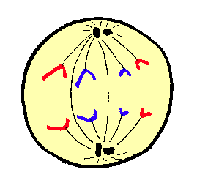
Most topics covered in Chapter 8 and 10-13 of HRW Modern Biology!

MC.2.B.8 Describe the main events in the cell cycle, including the differences in plant and animal cell division:
- What happens to a cell during interphase?

- Name the 3 parts of interphase.

- When during interphase is DNA copied?

- Define mitosis.

- Define Cytokinesis.

MC.2.B.9 List in order and describe the stages of mitosis:
- Describe everything that happens during Prophase.

- Describe everything that happens during Metaphase.

- Describe everything that happens during Anaphase.

- Describe everything that happens during telophase.

- How does cytokinesis in plants differ from cytokinesis in animal cells?

MC.2.B.10 Analyze the meiotic maintenance of a constant chromosome number from one generation to the next. (HINT: Tell the chromosome number for the parent, gametes, and offspring --- monoploid or diploid.)
- Parent chromosome number?
- Gamete (egg & Sperm) chromosome number?
- Offspring chromosome number?
- What process --- mitosis or meiosis--- reduces the chromosome number?
- What process --- union of egg & sperm --- restores the chromosome number?
HE.5.B.1 Model the components of a DNA nucleotide and an RNA nucleotide.
- SKETCH and LABEL a DNA nucleotide.

- What 3 things make up and RNA nucleotide?

HE.5.B.2 Describe the Watson-Crick double helix model of DNA, using the base-pairing rule (adenine-thymine, cytosine-guanine).
- What 2 things make up the Sides of DNA?

- Name the bonds that join the DNA sides.

- In the center of DNA, a P_____________ base pairs with a P____________ base.

- Nitrogen bases are bonded with H______________ bonds.

HE.5.B.3 Compare and contrast the structure and function of DNA and RNA.
 | DNA | RNA
SHAPE?
BASES?
SUGAR?
LOCATED WHERE IN CELL?
FUNCTION?

HE.5.B.4 Describe and model the processes of replication, transcription, and translation.
 | REPLICATION | TRANSCRIPTION | TRANSLATION
PURPOSE
NUCLEIC ACID(S) INVOLVED?
WHERE OCCURS?
HE.5.B.5 Compare and contrast the different types of mutation events.
- What is a point mutation?

- What is a frameshift mutation?

- What is a deletion?

- What is inversion?

HE.5.B.6 Identify effects of changes brought about by mutations:
- Beneficial changes?

- Harmful effects?

UNIT 5 - HEREDITY AND EVOLUTION - Genetics 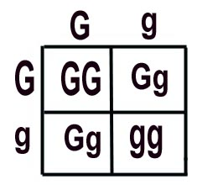

Most topics covered in Chapters 9, 12, and 14 - 16 of HRW Modern Biology!

HE.4.B.1 Summarize the outcomes of Gregor Mendel’s experimental procedures.
- Who is Gregor Mendel?
- Describe his work and the results he obtained from crossing garden peas.

HE.4.B.2 Differentiate among the laws and principles of inheritance:
- State the Law of Dominance.

- State the law of Segregation.

- State the Law of independent assortment.

HE.4.B.3 Use the laws of probability and Punnett squares to predict genotypic and phenotypic ratios. (HINT: Choose one pea plant trait of Gregor Mendel and work a P1, F1, and F2 cross showing all genotypes, phenotypes, and ratios.
USE PEA COLOR --- GREEN is dominant and YELLOW is recessive.
- P1 CROSS

- F1 Cross

- F2 Crosses (SHOW BOTH CROSSES.)

HE.4.B.4 Examine different modes of inheritance: (HINT: Give meaning & example.)
- What is sex linkage?

- What is codominance and give an example?

- When does crossing-over occur?

- What are the results of crossing-over?

- What is incomplete dominance and give an example?

- What are multiple alleles and give an example?

HE.4.B.6 Evaluate karyotypes for abnormalities: (HINT: Also give examples of genetic disorders caused by monosomy & trisomy.)
- Define monosomy.
- Define trisomy.

- Which of the following are example(s) of trisomy --- Turner Syndrome, Down’s syndrome, or Klinefelter’s Syndrome?

HE.6.B.1 Compare and contrast Lamarck’s explanation of evolution with Darwin’s theory of evolution by natural selection
- Explain Lamarck’s Inheritance of Acquired Characteristics.

- According to Lamarck, why do giraffes have long necks?

- Was Lamarck’s theory correct?

- Explain Darwin’s Theory of Evolution by Natural Selection.

- According to Darwin, why do giraffes have long necks?
- Was Darwin’s theory correct?
HE.6.B.4 Illustrate mass extinction events using a time line. (HINT: Use your geologic table in your textbook to show mass extinction of organisms that correlate to the time scale BELOW.) 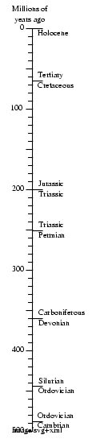
AGE OF FISHES
MANY FISH SPECIES DISAPPEARED
HE.6.B.5 Evaluate evolution in terms of evidence as found in the following:
- How does the fossil record help us determine the evolution of organisms?

- Today, scientists use DNA analysis or molecular biology in studying evolution. Explain how this helps.

- What is artificial selection?

- How can morphology (BODY FORM) show that organisms are related?

- How can embryology (EARLY DEVELOPMENT) show that organisms are related?

- Use the Galapagos Islands and the animals found there to explain how the geographic distribution of related species shows evolution.

- How does the use of antibiotics and pesticides cause resistance in insects and bacteria?

HE.6.B.6 Compare the processes of relative dating and radioactive dating to determine the age of fossils.
- What is Relative Dating of fossils?

- In what type of rock are most fossils found?

- What is Radioactive Dating of fossils and what isotopes are used?

- What is meant by half-life of a radioactive isotope?

- If ¹¹Be (radioactive beryllium) has a half-life of 13 seconds and you start with 20 grams, how much is left after ---
  - 13 seconds?
  - 26 seconds?
UNIT 6 - CLASSIFICATION AND DIVERSITY OF LIFE – Taxonomy & Microbes

Most topics covered in Chapters 18 and 23-26 of HRW Modern Biology!
HE.6.B.7 Interpret a Cladogram.
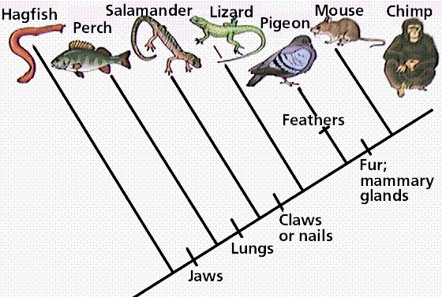

- Name the characteristics that the chimp shows on the Cladogram.

- On the Cladogram, which organism(s) does NOT have jaws?

- Name the organisms that share only fur and mammary glands?

- Which organisms do NOT have claws and nails?

- What emergent characteristic (NEW) is found in only one organism on the Cladogram? What is the organism?
- How many organisms have jaws but not claws? Name them.

CDL.7.B.1 Differentiate among the different domains:
- What organisms are in the domain Bacteria?

- Are they prokaryotes or eukaryotes?

- Describe the domain Archaea.

- Name 3 organisms in the domain Archaea.

- Are they prokaryotes or eukaryotes?

- Describe the domain Eukarya.

- Give at least 3 examples of the domain Eukarya.

- Are they prokaryotes or eukaryotes?

CDL.7.B.2 Differentiate the characteristics of the six kingdoms:
- Give the characteristics of Eubacteria.

- Give the characteristics of Archaea.

- Give the characteristics of Protista.

- Give the characteristics of Fungi.

- Give the characteristics of Plantae.

- Give the characteristics of Animalia.

CDL.7.B.3 Identify the seven major taxonomic categories. (HINT: List them in order broadest to most specific.)

KINGDOM P______________ C__________ O___________

F___________ G_______________ SPECIES

CDL.7.B.4 Classify and name organisms based on their similarities and differences applying taxonomic nomenclature using dichotomous keys. (HINT: USE THE FOLLOWING KEY TO IDENTIFY THESE ORGANISMS.)
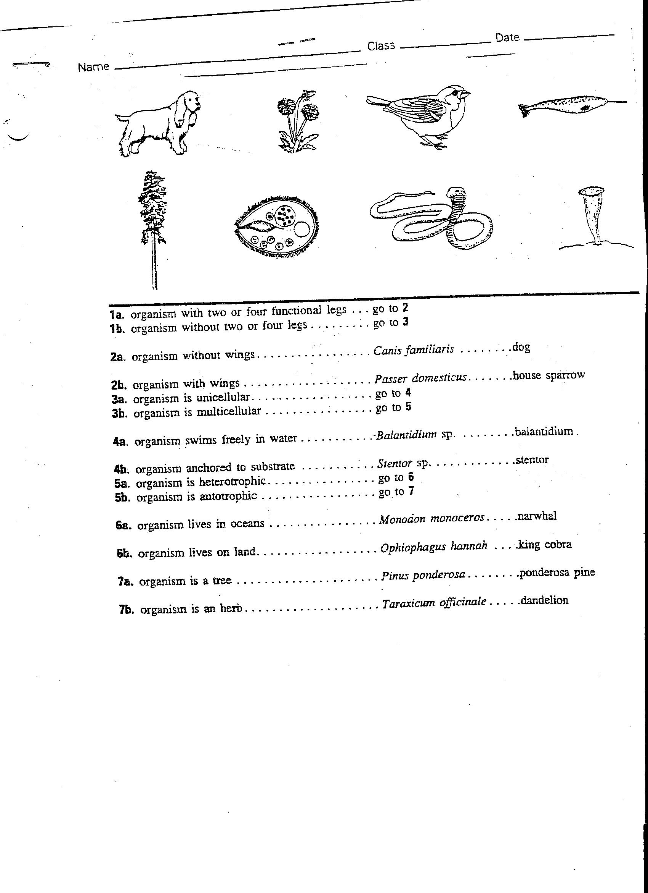
CDL.7.B.6 Compare and contrast the structures and characteristics of viruses (lytic and lysogenic cycles) with non-living and living things.
- Virus Characteristics?

- Steps of the Lytic Cycle?

- Steps of the Lysogenic Cycle?

CDL.7.B.7 Evaluate the medical and economic importance of viruses.
- Medical importance of viruses?

- Economic importance of viruses?

CDL.7.B.9 Classify bacteria according to their characteristics and adaptations.

- Characteristics of bacteria?

CDL.7.B.10 Evaluate the medical and economic importance of bacteria.

- Medical importance of bacteria?

- Economic importance of bacteria?

CDL.7.B.11 Describe the characteristics used to classify protists:
- Plant-like protists characteristics?

- Animal-like protists characteristics?

- Fungal-like protists characteristics?

CDL.7.B.13 Compare and contrast fungi with other eukaryotic organisms.
FUNGI
- Examples?

- Characteristics?

- Functions?
UNIT 7 - CLASSIFICATION AND DIVERSITY OF LIFE 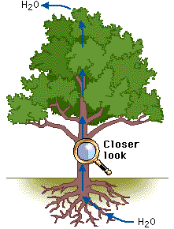

Most topics covered in Unit 7 PLANTS and Units 8 & 9 ANIMALS, HRW Modern Biology Textbook!
CDL.7.B.8 Compare and contrast life cycles of familiar organisms
- Explain alternation of generations in plants.

CDL.7.B.15 Differentiate between vascular and nonvascular plants.
- Define Vascular Plants.

- Name the 2 vascular tissues that carry food and water.
- Define Nonvascular Plants.

- Give an example of a nonvascular plant.

CDL.7.B.16 Differentiate among cycads, gymnosperms, and angiosperms.
- Describe Cycads.

- Describe Gymnosperms.
- Describe Angiosperms.

- All 3 of these plants reproduce by forming S__________.

CDL.7.B.17 Describe the structure and function of the major parts of a plant:
 | MAIN PARTS | FUNCTION(S)
ROOTS
STEMS
LEAVES
FLOWERS
CDL.7.B.18 Relate the structure of plant tissue to its function

 | STRUCTURE | FUNCTION(S)
EPIDERMAL
GROUND
VASCULAR

CDL.7.B.8 Compare and contrast life cycles of familiar organisms
- Explain sexual reproduction.

- Explain asexual reproduction.

- Explain metamorphosis in insects.

CDL.7.B.20 Identify the symmetry of organisms: (HINT: Describe the symmetry & give an example.)
 | DEFINITION | ORGANISM
ASYMMETRY
RADIAL SYMMETRY
BILATERAL SYMMETRY
CDL.7.B.21 Compare and contrast the major invertebrate classes according to their nervous, respiratory, excretory, circulatory, and digestive systems.

USE THESE TERMS TO HELP COMPLETE THE TABLE!
DIGESTION – amebocytes, gastrovascular cavity, gut
RESPIRATION - simple diffusion, moist skin, tracheal tubes & spiracles, book lungs, skin gills
CIRCULATION – cell-to-cell, OPEN circulation, CLOSED circulation
EXCRETION – simple diffusion, flame cells, nephridia, malpighian tubules, green glands
SUPPORT – sponging & spicules, endoskeleton, exoskeleton, limestone shell, mantle, hydrostatic skeleton

 | Digestion | Respiration | Circulation | Excretion | Support
SPONGES
CNIDARIAN
FLATWORM
ROUNDWORM
ANNELIDS
MOLLUSKS
ARTHROPODS
ECHINODERM
CDL.7.B.22 Compare and contrast the major vertebrate classes according to their nervous, respiratory, excretory, circulatory, digestive, reproductive and integumentary systems.

USE THESE TERMS TO HELP COMPLETE THE TABLE!
DIGESTION – esophagus, stomach, crop, gizzard, intestines
RESPIRATION -gills, moist skin, lungs
CIRCULATION – 2 chambered heart, 3 chambered heart, 4 chambered heart
EXCRETION – kidneys, cloaca, anus
SUPPORT – endoskeleton, hollow & fused bones, fur or hair, scaled skin, feathers

 | Digestion | Respiration | Circulation | Excretion | Support
FISH
AMPHIBIAN
REPTILES
BIRDS
MAMMALS

UNIT 8 - ECOLOGY AND BEHAVIORAL RELATIONSHIPS 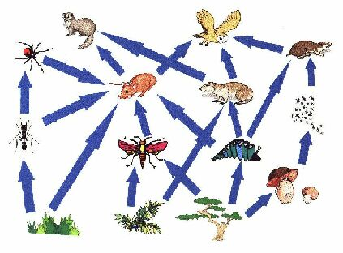
Most answers will be found in Unit 5 of HRW Modern Biology!

EBR.8.B.1 Cite examples of abiotic and biotic factors of ecosystems.
- Define abiotic factors and give 2 examples.

- Define biotic factors and give 2 examples.

- Which are the living factors?

EBR.8.B.2 Compare and contrast the characteristics of biomes.
BIOME | Climate | Geographic location | Main Vegetation | Main  Consumers
Rainforest
Tundra
Taiga
Grasslands
Deserts
EBR.8.B.3 Diagram the carbon, nitrogen, phosphate, and water cycles in an ecosystem. (HINT: MAKE A SKETCH OF EACH INCLUDING EXPLANATIONS.)
- Carbon Cycle

- Nitrogen Cycle

- Phosphate Cycle

- Water Cycle

EBR.8.B.4 Analyze an ecosystem’s energy flow through food chains, food webs, and energy pyramids. (HINT: SKETCH & EXPLAIN EACH.)
- What is a food chain?

- What type of organism always begins a food chain?
- Write or draw a FOOD CHAIN.

- What is a food web?

- Write or draw a FOOD WEB.

- What is an energy pyramid?

- DRAW A FOOD PYRAMID and LABEL THE ORGANISMS at each level.

EBR.8.B.5 Identify and predict the factors that control population.
- Define predation.

- What types of things do organisms COMPETE for in an ecosystem?

- How does overcrowding affect a population’s size?

- Explain the importance of available water to organisms.

- Explain the importance of available nutrients to organisms.

- Explain the importance of available shelter to organisms.

EBR.8.B.6 Summarize the symbiotic ways in which individuals within a community interact with each other:
- Define commensalism.

- Give an example of commensalism.

- Define parasitism.

- Give an example of parasitism.

- Define mutualism.

- Give an example of mutualism.

EBR.8.B.7 Compare and contrast primary succession with secondary succession.
- Describe Primary Succession.

- Describe Secondary Succession.

EBR.8.B.8 Identify the properties of each of the five levels of ecology:
- What is an Organism?

- What is a Population?

- What is a Community?

- What is an Ecosystem?

- Define Biosphere.

EBR.9.B.1 Analyze the effects of human population growth and technology on the environment/biosphere.

- Discuss some of the impacts that man’s activities have had on the environment.

EBR.9.B.3 Assess current world issues applying scientific themes (e.g., global changes in climate, epidemics, pandemics, ozone depletion, UV radiation, natural resources, use of technology, and public policy)
- What is global warming?

- How has man’s activities added to global warming?

- What are some recent Epidemics/Pandemics that have occurred?

- Discuss our use of CFC’s and the Depletion of Ozone Layer.

- Discuss how the hole in our ozone layer and the resulting increase in UV Radiation can affect life on Earth.

- What are some natural resources we are depleting?

